**Laboratory Activity**

**Web Systems and Technology**

**Midterm**

Allana Rose A. Saligumba

Procedure:

* Open your individual unit and check your current PHP version using the command prompt see sample image below : Write the command in the black provided

_____________________________________________

* Then open the XAMPP control panel (see image)

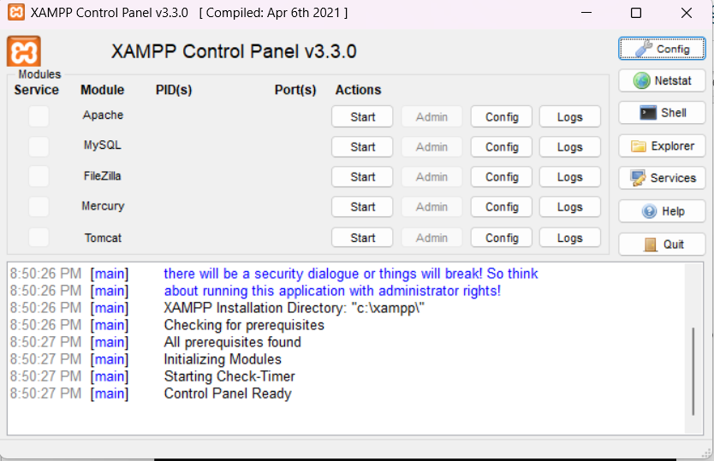

Make sure to click the Start button to open the Apache and MySQL

* Once it green your server is now running

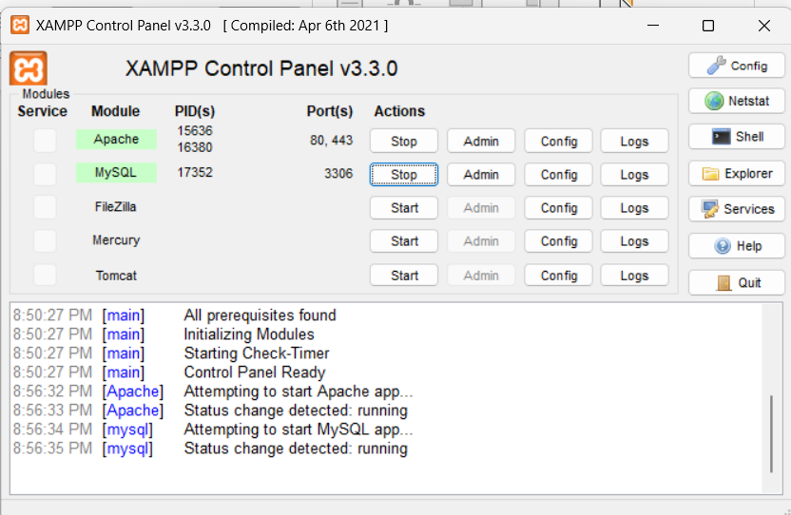

* Make sure to check the ports of Apache and MySQL as follows

* Your now ready to test your server
* Access the XAMPP dashboard in a browser
  + Open your preferred web browser and type http://localhost into the address bar and press **Enter**.
  + If XAMPP is working correctly, you will see the XAMPP welcome page, which confirms the Apache web server is running.

* + Alternatively, you can type http://127.0.0.1 to get the same result.
* Next, open your VS code app if the following Extension are available and properly installed
  + PHP server
  + Live server
  + PHP intelephense

* Once installed start your first PHP code

**First thing first create a folder inside your XAMPP**

* **Locate your root folder**. Open the XAMPP Control Panel and click the **Explorer** button to navigate to your installation directory, typically **C:\xampp\ on Windows**.

* **Find htdocs**. Open the htdocs folder. This is the root directory for all your web projects.

* **Create a project folder**. Create a new folder inside htdocs for your project (e.g., C:\xampp\htdocs\MyWebsite(any name you set)).
* **After creating the Filename inside htdocs, open your VS CODE app then**
* **Then locate this folder as show in the image below**

* **Save your projects**
  + you need to save your files in the correct directory.
* Create at least one sample code using the following.
  + Concatenate String

* + Math Functions

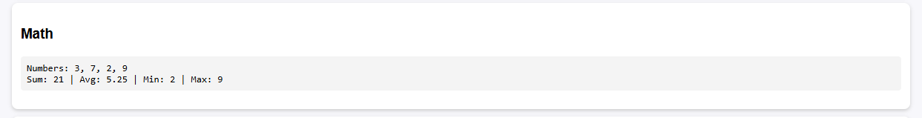

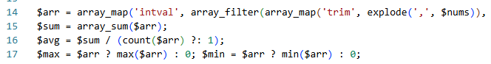

* + Loops

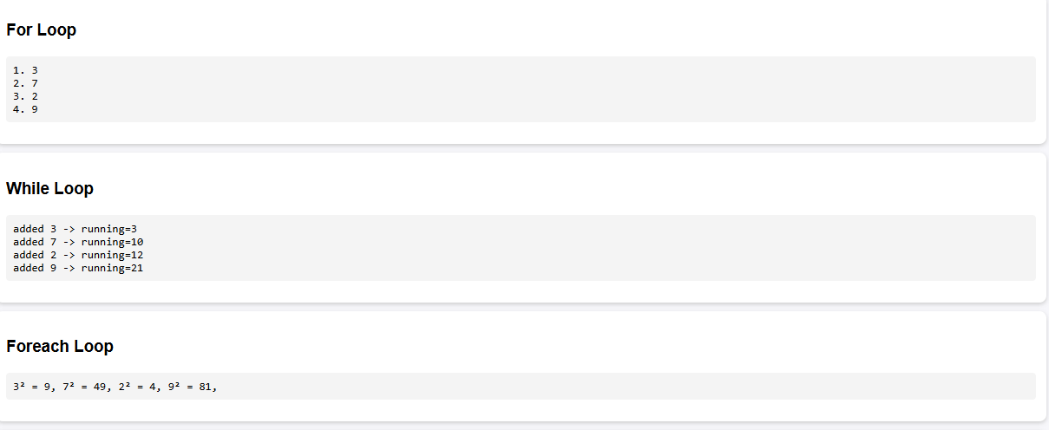

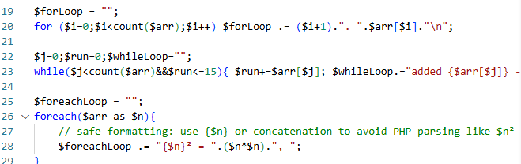

* + Constants

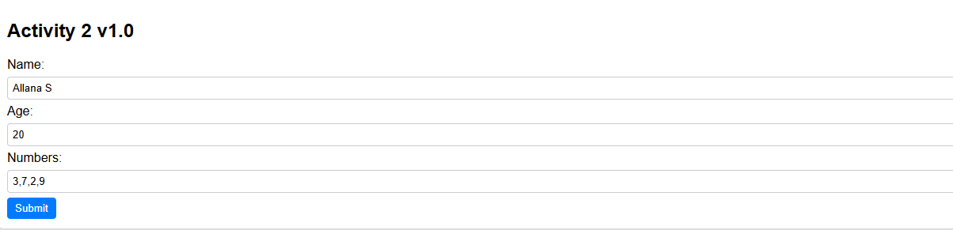

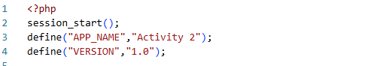

* + PHP Superglobals





* + Sample Form Handling

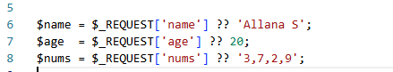

Note: Don’t forget to save your sample with PHP extension (e.g index.php)

* Display an output for each sample
  + **Access your project**. To view your website, go to your browser then type  <http://localhost/MyWebsite> (or the name you set)  . If you created a specific file, such as index.php, you would visit <http://localhost/MyWebsite/index.php> (or the filename you saved)

